🩹 Comprehensive Sports-Medicine Analysis: Right-Wrist TFCC Injury & Return-to-Gym Plan
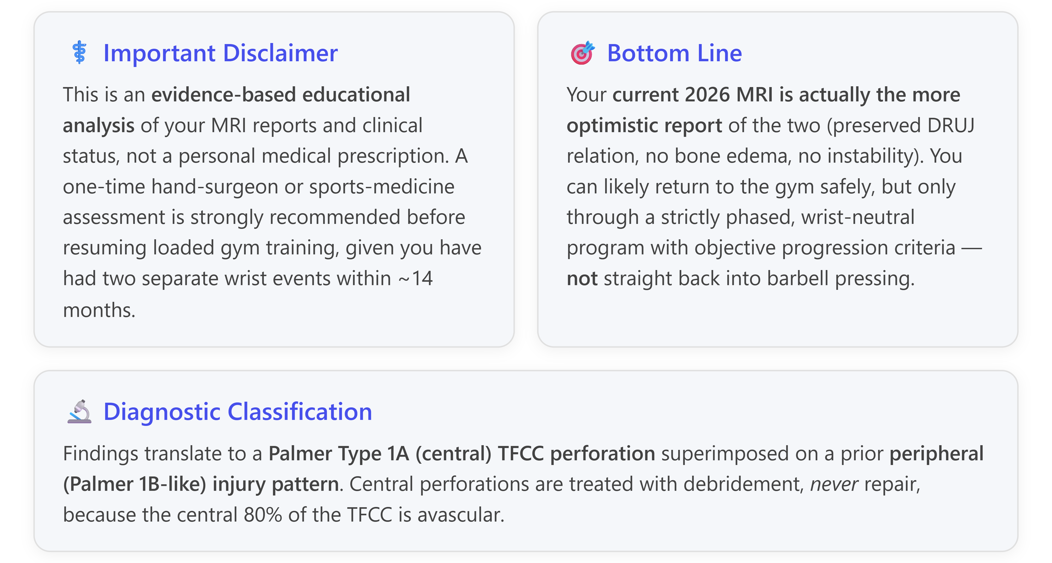

1. Interpreting Your Two MRI Reports

1.1 Report 1 (02 Nov 2024) — Peripheral-pattern injury
Your 2024 report described marrow edema of the ulnar styloid process with elevated signal of the TFCC at its ulnar attachment ("possibly partially detached") plus subtle wrist joint effusion. Everything else — carpal tunnel, tendons, articulations, marrow of other bones — was normal.
Why this matters: Ulnar styloid bone marrow edema is one of the strongest MRI markers of a peripheral (ulnar-sided) TFCC injury. A 2026 multiparametric study of 76 arthroscopically-confirmed cases showed ulnar styloid marrow edema was present in 82.9% of peripheral tears vs. only 11.1% of central tears (OR 0.14, p<0.001). The pattern "elevated signal at ulnar attachment + partial detachment" is exactly how a Palmer Type 1B / peripheral ulnar avulsion presents on MRI, though the radiologist explicitly recommended MR arthrography for definitive assessment.

1.2 Report 2 (09 Feb 2026) — Central-pattern lesion, no instability signs
Your 2026 report is quite different: central defect of the triangular fibrocartilage with mild distal radioulnar joint (DRUJ) fluid, but with preserved DRUJ relation, preserved scapholunate & lunotriquetral distances, normal marrow, no sizable effusion, intact tendons and carpal tunnel. Opinion: central perforation of the TFCC.
Why this matters: This is textbook Palmer Type 1A morphology — a central perforation of the fibrocartilage disc. The TFCC is anatomically made of dorsal/volar radioulnar ligaments, central articular disc, meniscus homolog, ulnar collateral ligament, ECU subsheath, and the ulnolunate/ulnotriquetral ligament origins. The central 80% of the disc is avascular, whereas only the peripheral 10–40% carries a real blood supply — this vascular pattern drives all treatment decisions.
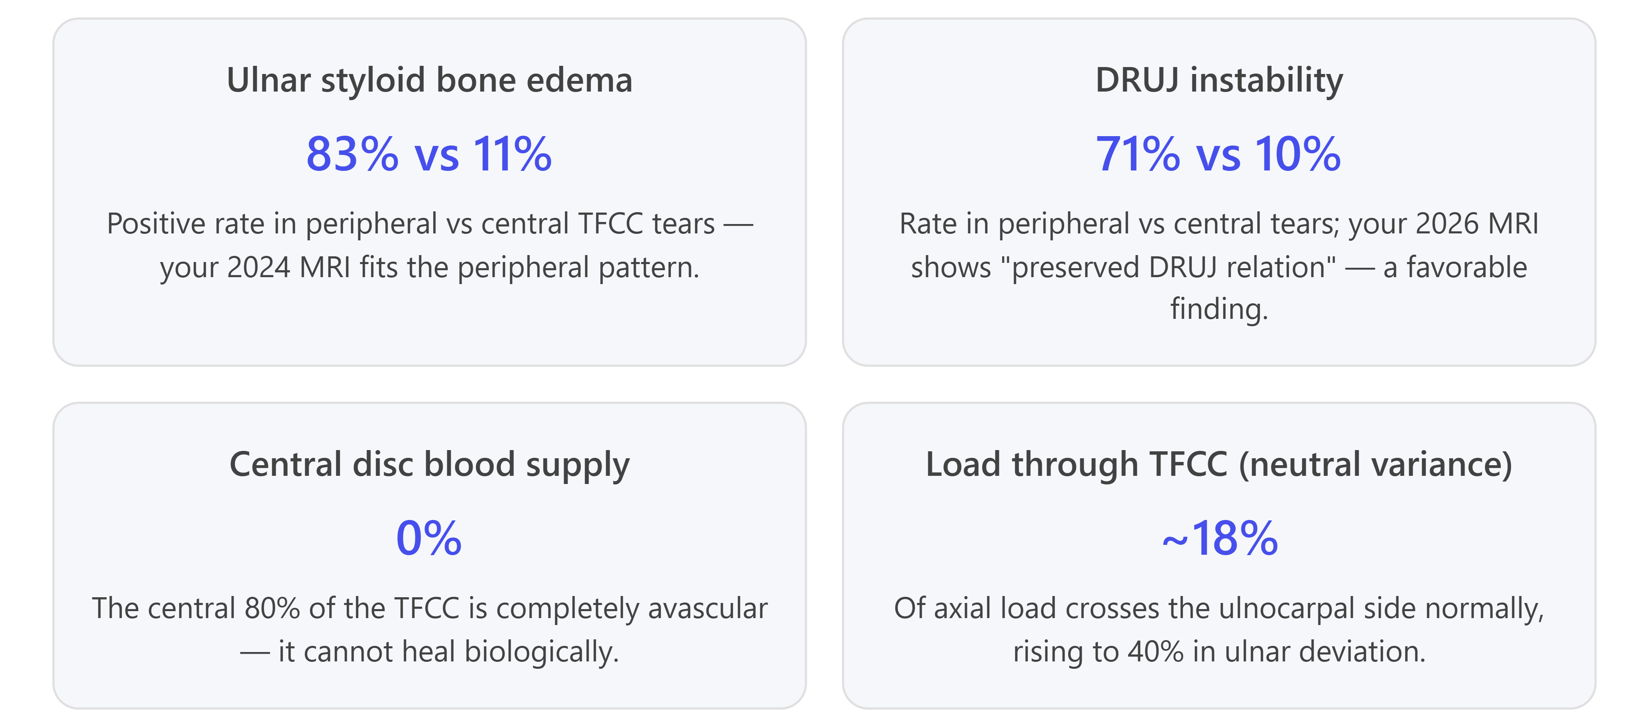

2. Are the Two Injuries Related? (Question 2)

2.1 Yes — they are almost certainly the same disease process, but the second event is not a failure of your first treatment
Two things can both be true here:
- The 2024 lesion was a peripheral (probably Palmer 1B–pattern) partial detachment — signal at the ulnar attachment plus ulnar styloid marrow edema is the classic MRI fingerprint of that pattern. Peripheral injuries can heal because they have a blood supply, especially when immobilized above the elbow (Muenster/sugar-tong style), which is exactly what your 6-week above-elbow cast provided. Above-elbow immobilization is specifically preferred for peripheral TFCC healing because it blocks forearm rotation.
- The 2026 lesion is a central perforation — a defect within the disc itself, not at the attachment. This is a different location within the same complex, and central tears do not heal on their own regardless of treatment because there is no blood supply to the central disc.
So the injuries are related in that your TFCC as a whole is fragile and has been repeatedly overloaded, but the 2026 finding does not necessarily mean your 2024 injury failed to heal. It more likely means the central disc — which was probably already thinning or vulnerable — perforated when you resumed loading. Classic sports-medicine data show that:
- Up to 39/103 asymptomatic volunteers have MRI-detectable TFCC abnormalities, and 23 had full tears; TFCC changes are near-universal above age 60.
- 59% of symptomatic patients and 19% of asymptomatic controls have TFCC perforations on arthrography.
- Traumatic and degenerative central lesions are notoriously hard to distinguish on imaging alone.

2.2 Why did symptoms come back after ~1 month back at the gym?
That short lag is classic for subclinical, biomechanically-vulnerable TFCC tissue: you likely returned before your dynamic ulnar stabilizers (ECU, pronator quadratus) had regained full endurance. When those muscles fatigue, load shifts back onto the passive TFCC, and any residual lesion or fragile fibrocartilage progresses.

3. Severity, Prognosis & Return-to-Gym Safety (Question 1)
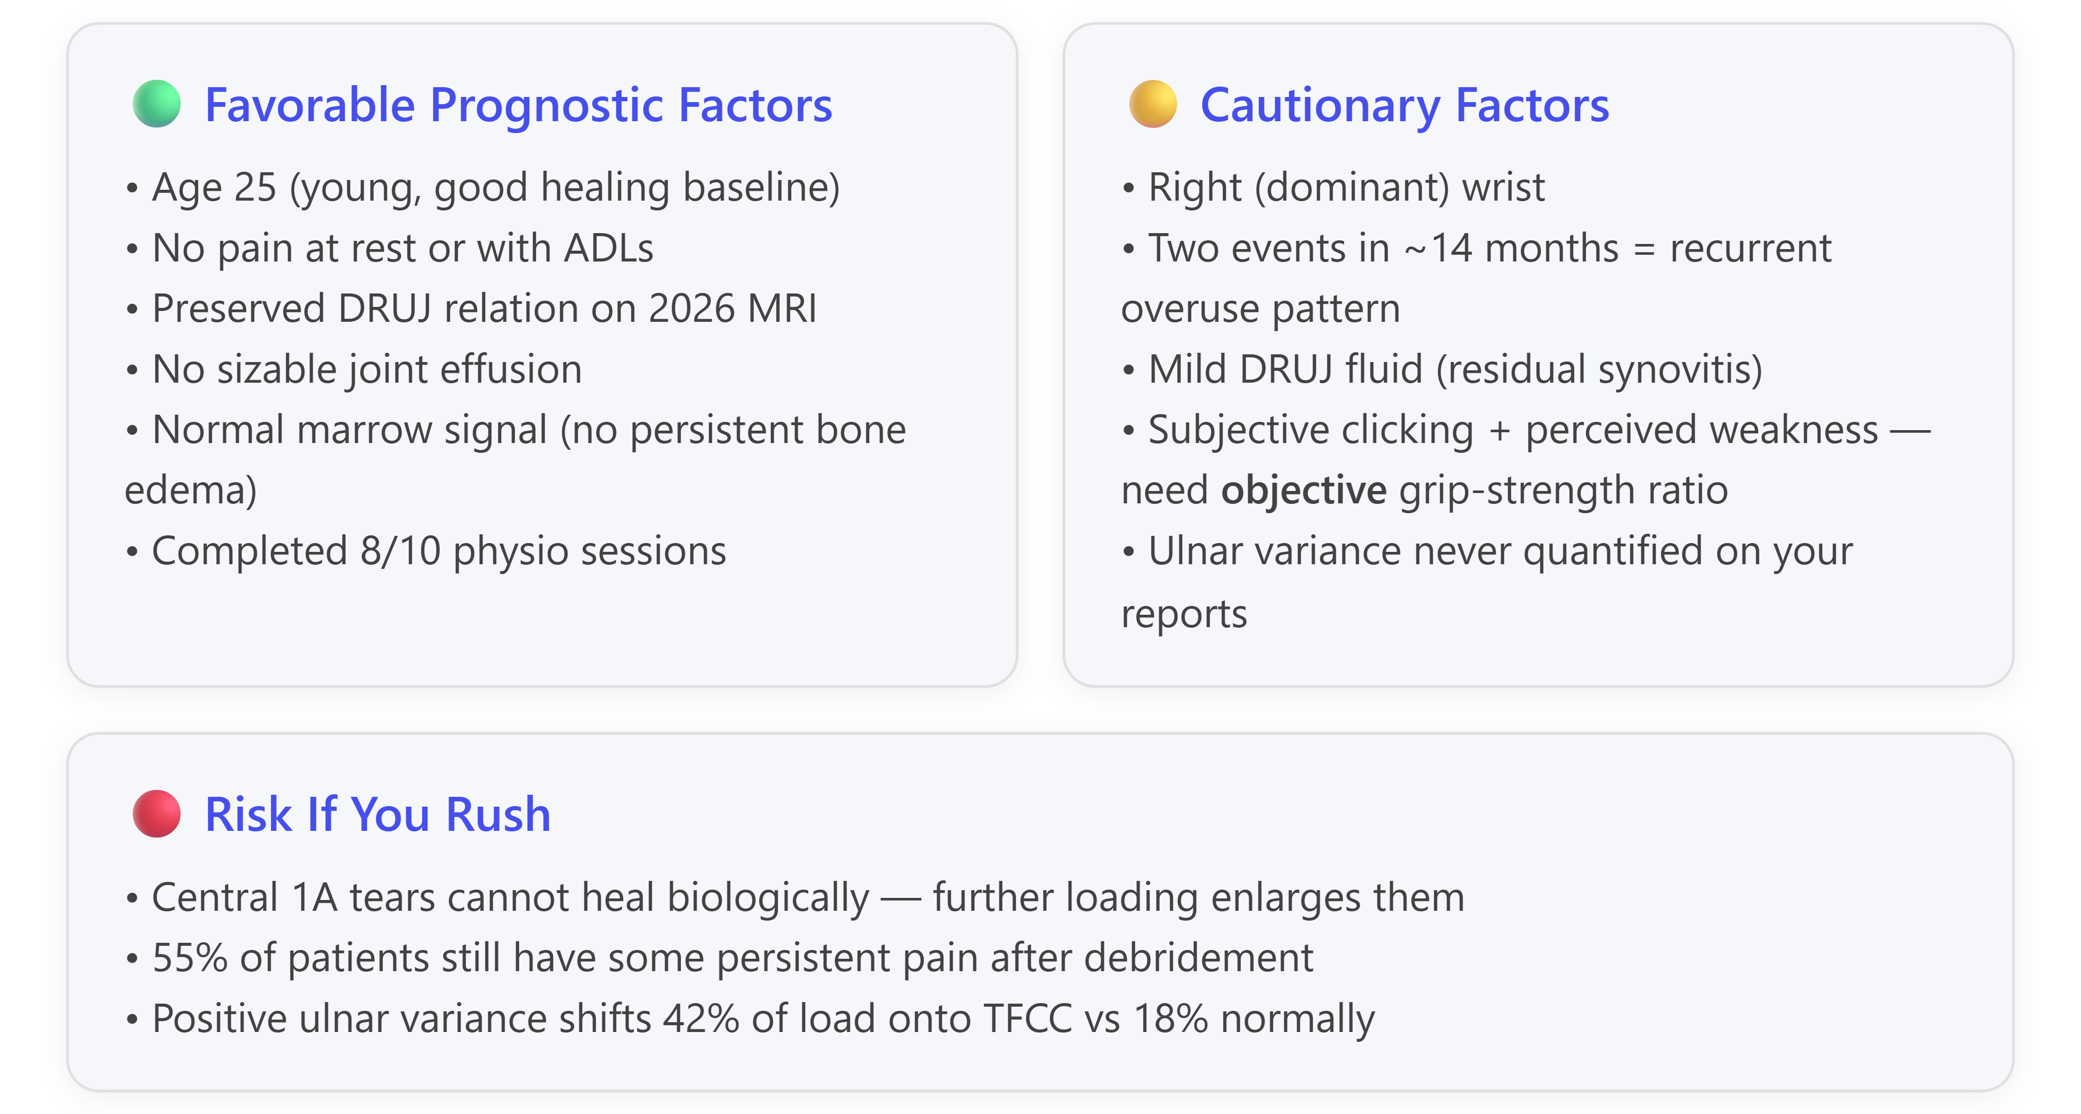

3.1 Overall severity
Moderate. A central Palmer 1A perforation with an intact DRUJ and no other ligamentous injury is at the more favorable end of the spectrum — it is the exact injury described in the literature as having "~30% complete recovery by 6 months and ~50% by 1 year with conservative treatment alone" when there is no DRUJ instability. Studies comparing conservative care vs arthroscopic debridement in TFCC lesions with a stable DRUJ show essentially equivalent outcomes at 22 months: DASH score 16.8 vs 22.1 and Modified Mayo Wrist Score 94.3 vs 87.2 — a strong argument for continuing conservative management first.

3.2 Is it safe to return to the gym?
Yes — with conditions. Because you are pain-free at rest and with daily activities, and your DRUJ is imaging-stable, you meet the entry criteria for a graduated return. However, you should NOT simply resume your previous routine. The evidence-based checklist below should be satisfied before you start Phase 2 loading:
Return-to-gym criterion | Target | Rationale
Pain at rest | 0/10 | ✅ You already meet this
Pain with daily activity | 0/10 | ✅ You already meet this
Grip strength ratio (dynamometer, R:L) | ≥ 80% | Standard sports-medicine benchmark; measure before starting
Full pain-free wrist ROM (flex/ext/rad/ulnar/pron/sup) | Symmetric | Any restriction to end-range supination is a red flag
Fovea sign | Negative | High-sensitivity test for foveal TFCC pathology (95% sens, 87% spec)
Piano-key test / DRUJ ballottement | Negative | Confirms clinical DRUJ stability, not just imaging stability
Painless press test (push up out of a chair) | Yes | Screens axial-loading tolerance
The clicking you notice is common after any TFCC injury and by itself is not dangerous if it is painless and not accompanied by locking, catching, or a sensation the wrist "slips." A painful click, especially with forearm rotation, is a different story and needs re-imaging.

3.3 Do you need to avoid certain training permanently?
Almost certainly no. Full return to lifting is the expected outcome. Only the small minority who have persistent DRUJ instability, positive ulnar variance >2 mm, or failed conservative therapy end up needing surgery — and even most of them return to activity within 3–6 months. The realistic long-term picture for you is:
- Bench press, deadlift, rows, curls, dips: fully returnable with wrist-neutral technique + occasional wrist-wrap support for maximal lifts.
- Push-ups & handstands (full wrist extension under bodyweight): returnable with push-up handles / neutral grip; only extreme/heavy versions (weighted dips, planche work) require long-term caution.
- Kettlebell snatches, heavy Olympic cleans, rope climbs: probably lifelong "yellow-light" activities that require deliberate warm-up, moderate volume, and a wrist wrap.

4. Exercise-by-Exercise Analysis (Question 3)
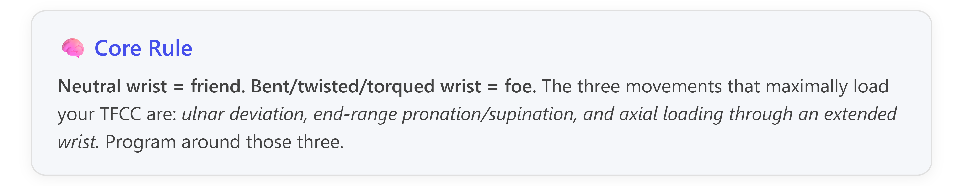

4.1 Push-ups
Verdict: Temporarily avoid → gradually reintroduce over 8–12 weeks.
A standard push-up forces the wrist into ~80–90° extension while your entire bodyweight axially loads through it — the biomechanical worst-case scenario for a central TFCC perforation. Evidence-based sequence:
- Weeks 0–4: wall push-ups (arm's length from wall), 3×10–15.
- Weeks 4–6: table/counter push-ups (elevated), 3×10–12.
- Weeks 6–8: knee push-ups, 3×8–10 — only if elevated ones are completely pain-free. Use push-up handles or hex dumbbells to keep the wrist in neutral.
- Weeks 8+: full push-ups with push-up handles / hex-dumbbells; add ROM depth gradually.
Long-term: Always use push-up handles or perform on fists (with a mat) if you feel wrist stress. Plank on forearms/elbows instead of extended wrists whenever possible.

4.2 Pull-ups
Verdict: Restart in stages, prefer neutral-grip bar.
Pulling is generally kinder to the TFCC than pushing because there is less axial load through the wrist. Progression:
- Dead hangs: 10–30 seconds, neutral grip if possible; adds distraction (not compression).
- Eccentric-only: jump up, lower slowly (3–5s).
- Band-assisted pull-ups.
- Full pull-ups — neutral grip (parallel bars) is strongly preferred; pronated ("overhand") pulls generate more ulnar deviation and TFCC load.
Warning signs: Sharp ulnar-sided pain at the top of the pull, or catching sensation as you rotate.

4.3 Bench press
Verdict: Yes, but restart at 60–70% of pre-injury 1RM and progress ~5% per week.
- Weeks 0–6: skip barbell bench entirely.
- Weeks 6–10: dumbbell floor press with neutral (hammer) grip — floor press removes the deep bottom-out stretch that irritates the wrist.
- Weeks 10–14: neutral-grip DB bench press or Smith-machine bench with wrist wraps.
- Weeks 14+: barbell bench starting at 60–70% of pre-injury 1RM, +5% weekly. WristWidget or wrist wraps recommended for pressing >70% 1RM.
Consider a fat bar / Fat Gripz: the larger diameter reduces the extreme wrist extension and evenly distributes force.

4.4 Wrist-loaded exercises
Verdict: Reintroduce isometrics first, then eccentrics, then isotonics — but keep some caution long-term.
Direct wrist loading is central to rehab because you want to build the dynamic stabilizers (ECU, pronator quadratus) that protect the TFCC. Sequence:
- Isometrics in 6 directions (flexion/extension/radial/ulnar deviation/pronation/supination) — 3×10-second holds daily at 30% effort.
- ECU activation with a rubber band — the ECU is the key dynamic TFCC stabilizer.
- Pronator quadratus activation with band resistance.
- Wrist curls & reverse curls starting at 1 kg, +0.5 kg per week.
- Loaded pronation/supination (hammer curls held asymmetrically) — the most TFCC-sensitive movement, so introduce last.
- Eccentric extensions — excellent for tendon conditioning.

4.5 Barbells vs Dumbbells vs Machines — Priority Order
Modality | TFCC-safety | Why | When to use
Machines & cables | ⭐⭐⭐⭐⭐ | Fixed load path, no stabilization demand, control over wrist angle | Phases 1–3 (weeks 0–16). "Your best friends during recovery."
Dumbbells (neutral grip) | ⭐⭐⭐⭐ | Allow wrist to self-orient into a comfortable position; hammer/neutral grip minimizes supination stress | Phase 2 onwards (~week 6)
EZ curl bar / trap bar / fat bar | ⭐⭐⭐⭐ | Angled or thick grips reduce wrist extension and supination stress | Whenever you use "barbells" during Phases 3–4
Straight barbells (supinated / pronated) | ⭐⭐ | Fixed grip forces the wrist into end-range positions | Phase 4+ only, once fully asymptomatic
Kettlebells (swings, snatches) | ⭐ | Combine pronation, load, and velocity — high TFCC risk | Phase 5 only, and even then keep volume moderate
Equipment worth investing in: WristWidget brace (specifically designed for DRUJ compression), lifting straps (to reduce grip demand for rows/deadlifts), wrist wraps (compression for pressing), push-up handles / hex dumbbells (neutral wrist for floor exercises), EZ curl bar, therapy putty set.

5. Phased Return-to-Gym Plan (Question 4)
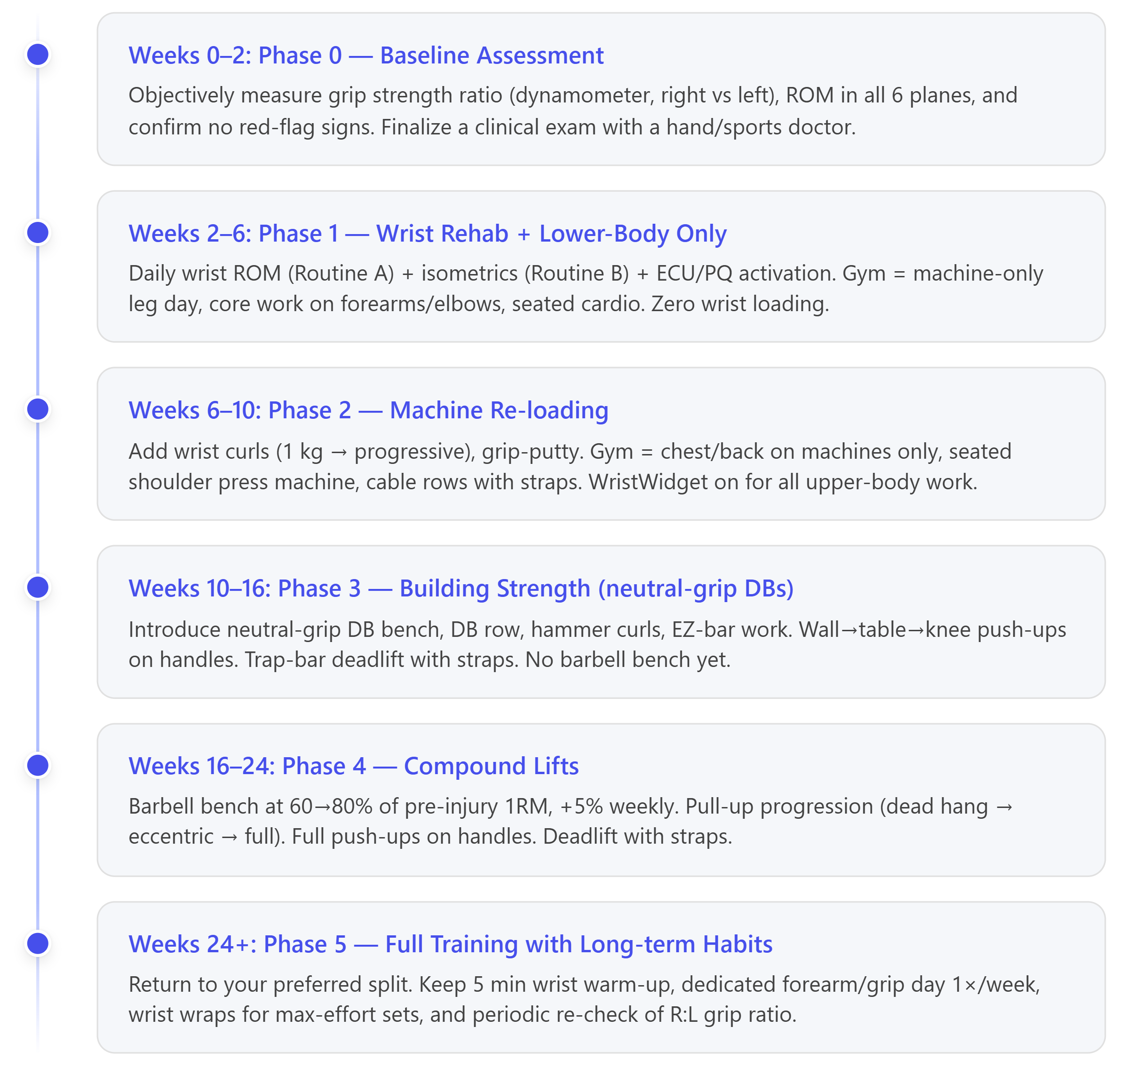

5.1 Progression rules (evidence-based)
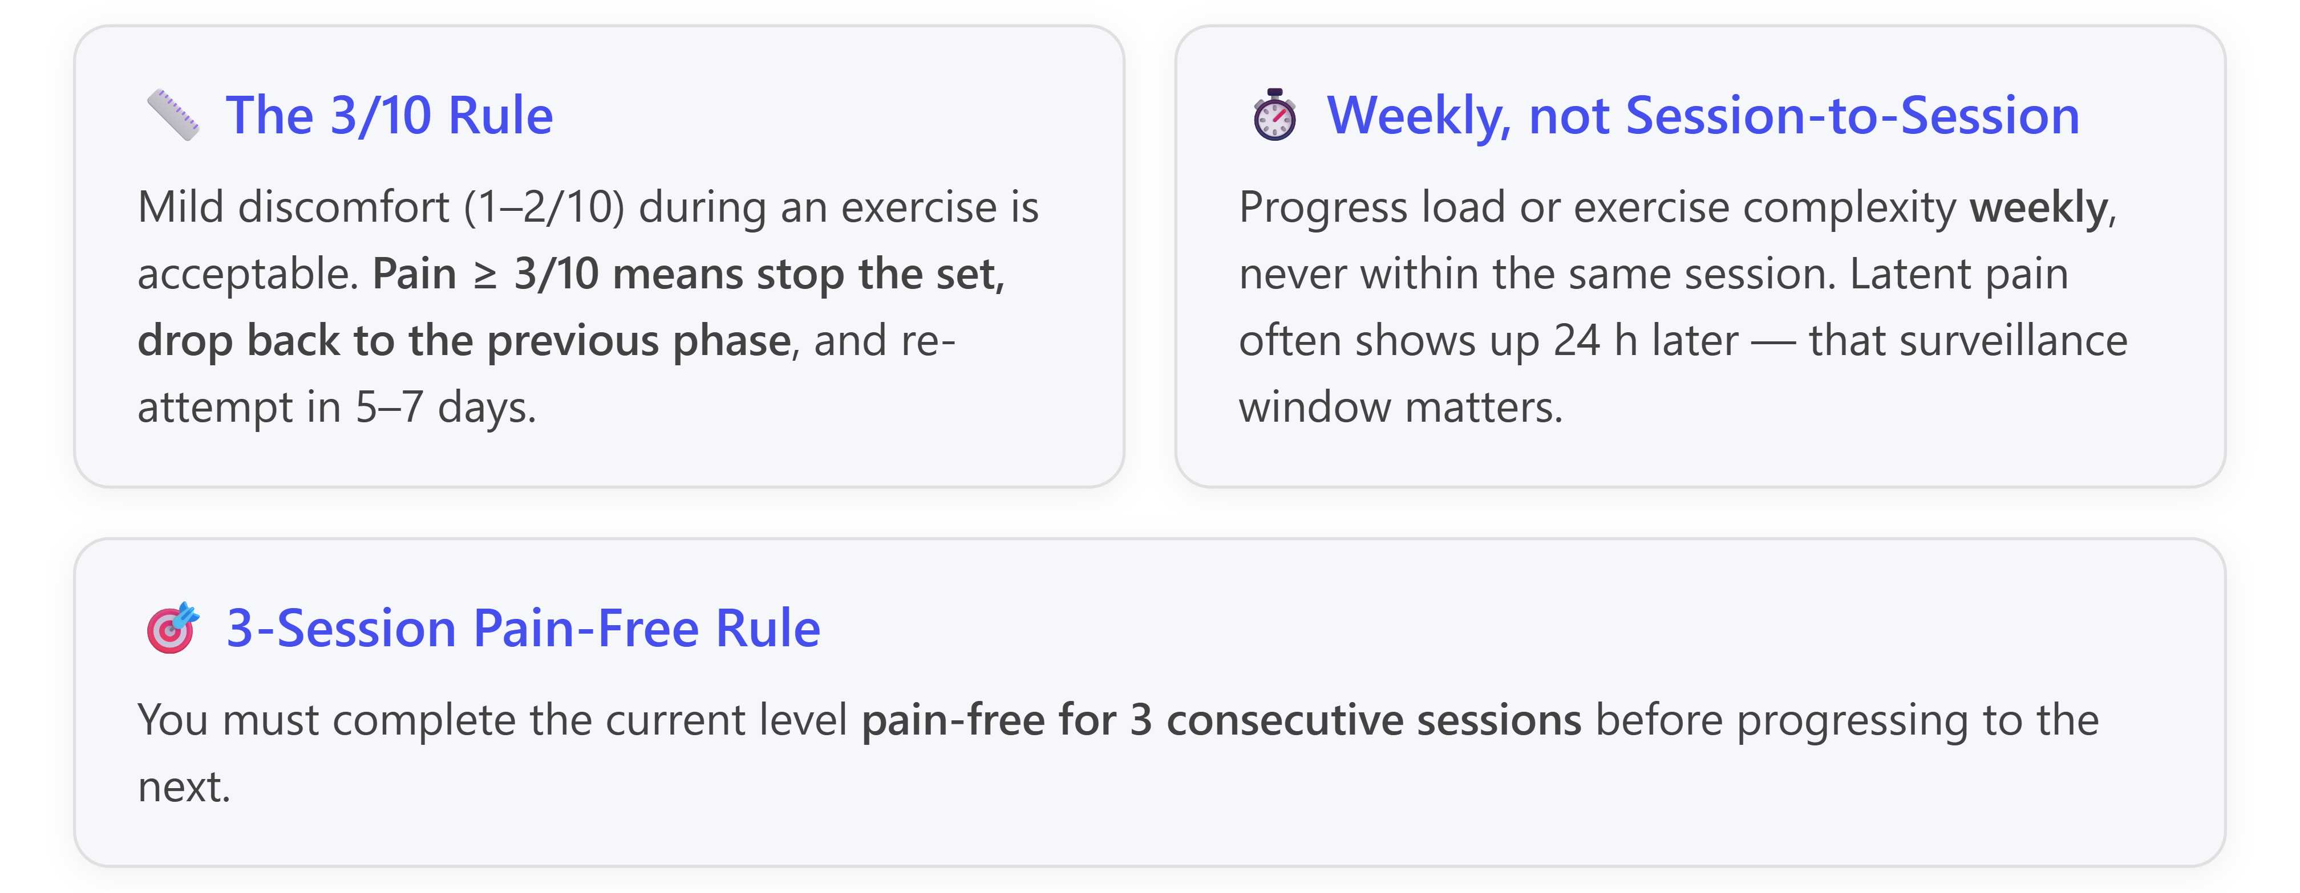

5.2 Sample weekly template (weeks 6–10, Phase 2)
Day | Session
Monday | Wrist ROM + isometrics (rehab) + Leg day (machines, no barbell)
Tuesday | Wrist ROM + ECU/PQ activation + putty grip + Chest/Shoulder machines (neutral grip)
Wednesday | Rest or 30 min stationary bike / walking
Thursday | Wrist ROM + isometrics + strengthening (light wrist curls) + Back day (chest-supported rows, lat pulldown neutral grip)
Friday | Wrist ROM + ECU/PQ activation + putty grip + Legs & core (forearm plank)
Saturday | Wrist ROM + isometrics + Arms day (hammer curls, cable pushdowns, machine preacher)
Sunday | Rest
Template adapted from published TFCC-rehab weekly programming.

5.3 Frequency & intensity limits
- Gym frequency: 3× per week initially → up to 4–5× per week from Phase 4.
- Load caps by phase: Phase 1 = bodyweight only; Phase 2 = machines only, RPE 6–7; Phase 3 = ≤60% 1RM equivalent DBs; Phase 4 = 60→80% 1RM barbell; Phase 5 = full loading.
- Volume caps: Keep upper-body volume ~60% of pre-injury baseline for the first 12 weeks, then progressively normalize.
- Rest day between upper-body sessions: 48 hours minimum through Phase 3, non-negotiable.

6. Risk Management: Red Flags & Re-Injury Risk (Question 5)

6.1 Warning signs that mean stop training immediately and re-consult
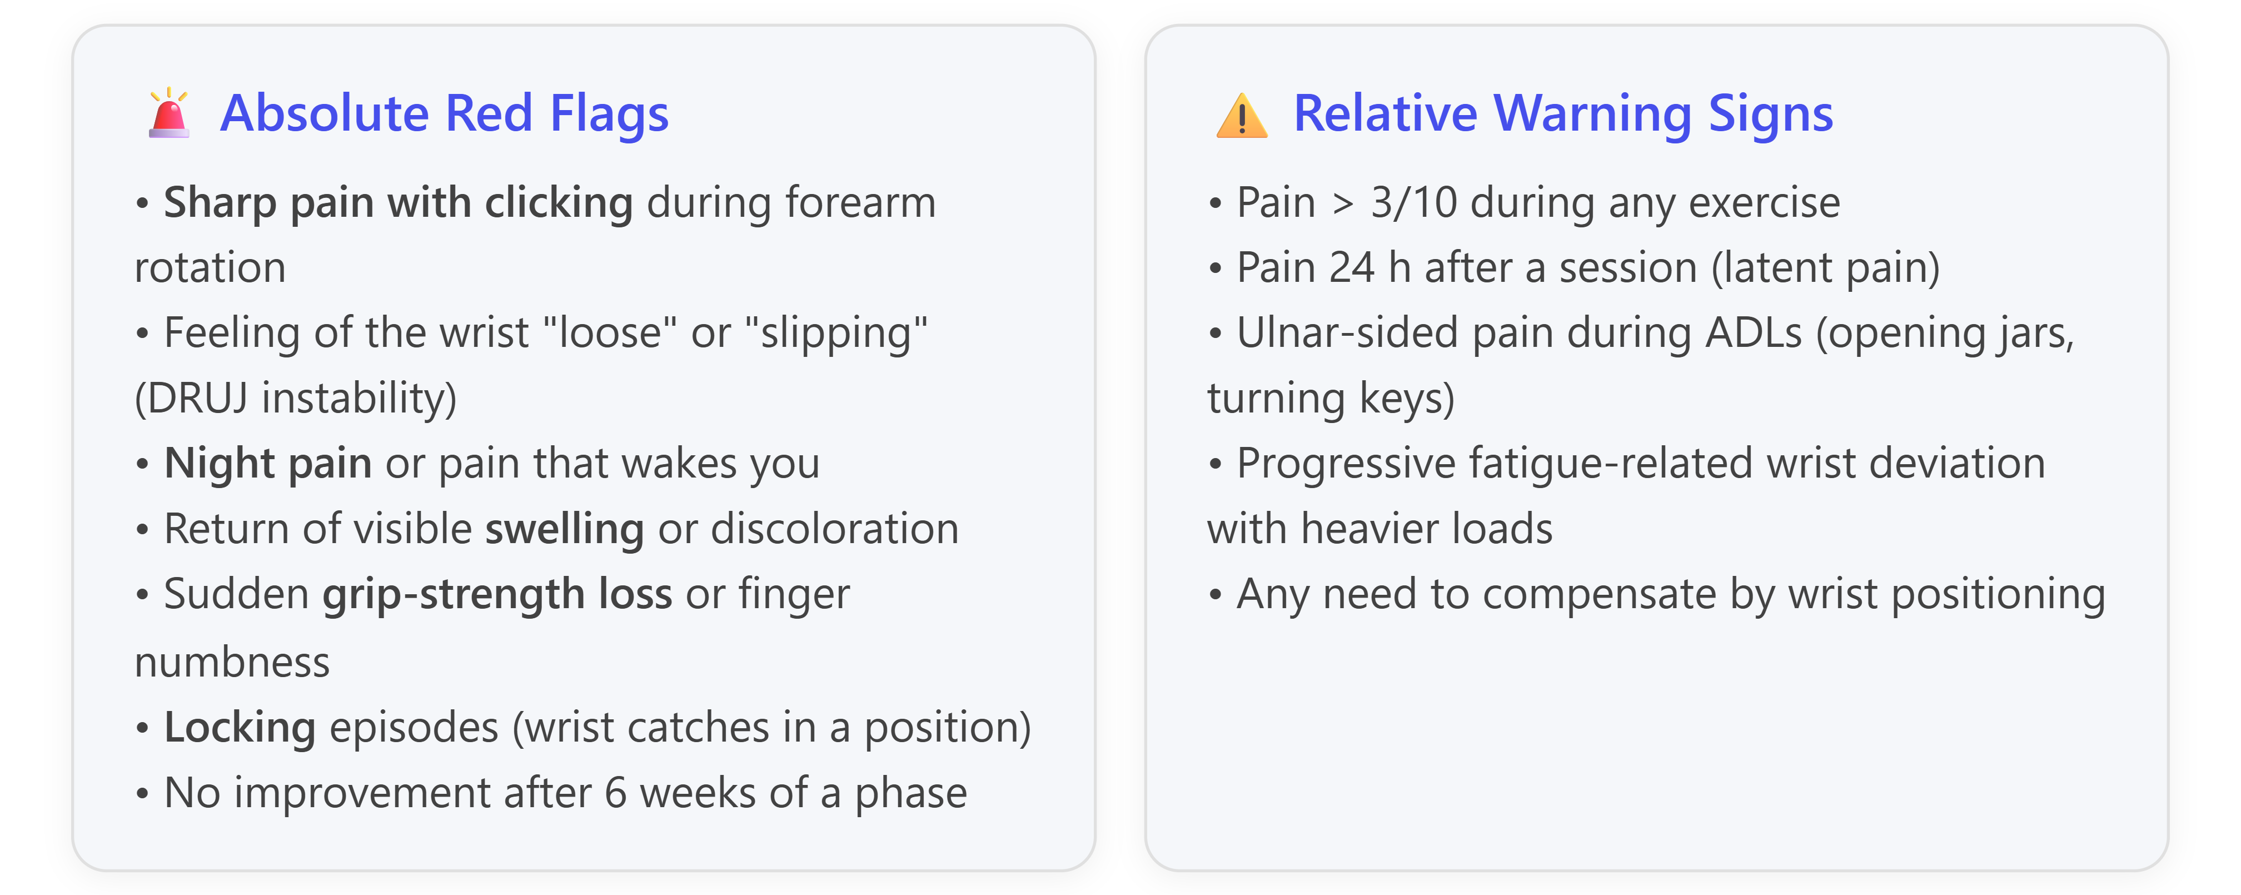
Adapted from TFCC rehab red-flag lists in current literature.

6.2 Factors that increase your re-injury risk
- Recurrence pattern already present — you have already had 2 events, so you are statistically more likely than a first-timer to have another.
- Dominant-side involvement — the right wrist is used more in daily life, so mechanical loading is unavoidable.
- Positive or dynamic ulnar variance (unknown in your case — see §7.1). Biomechanically, positive variance > +2.5 mm shifts 42% of axial load onto the ulnocarpal side, vs the normal 18%.
- Return too early or without objective grip strength testing.
- Ignoring dynamic stabilizer training (ECU + pronator quadratus).
- Programming errors: high-volume barbell bench, weighted dips, kettlebell swings/snatches, olympic cleans, heavy overhead pressing with pronated grip, straight-bar curls at maximal loads, front squats, wall walks/handstands.
- Fatigue-related loss of wrist control during long sessions.
- Chronic wrist extension typing/mouse use at work (relevant for you — you're an algorithm engineer, so watch ergonomics).

7. Medical Follow-up: MRI Arthrogram, Specialist, Surgery? (Question 6)

7.1 Do you need an MR arthrogram?
Not urgently, but consider it before any surgical decision. The evidence:
- Compared to conventional MRI, MR arthrography (MRA) is only slightly more accurate for TFCC lesions. A 150-patient study using arthroscopy as gold standard found:
  - 1.5 T wrist MRA: sensitivity 80%, specificity 100%, accuracy 90%
  - Conventional 1.5 T MRI: sensitivity 71%, specificity 75%, accuracy 73%
- The authors themselves conclude the small accuracy gain "could question whether this difference outweighs the burden and risks of an invasive procedure."
Practical recommendation for you:
- You do NOT need an MRA now because you have a known diagnosis, no DRUJ instability on your current MRI, and you're pain-free at rest.
- You WOULD benefit from MRA if any of the following happen: (a) symptoms return during Phase 3–4 loading; (b) a hand surgeon considers arthroscopy; (c) you develop DRUJ instability signs; (d) new peripheral (Palmer 1B/1C) tear is suspected.
Also, importantly, ask for weight-bearing plain radiographs with a "zero rotation PA" view to measure your ulnar variance. That single piece of data changes prognosis and surgical planning materially — and it's currently missing from your workup.

7.2 Should you see a specialist?
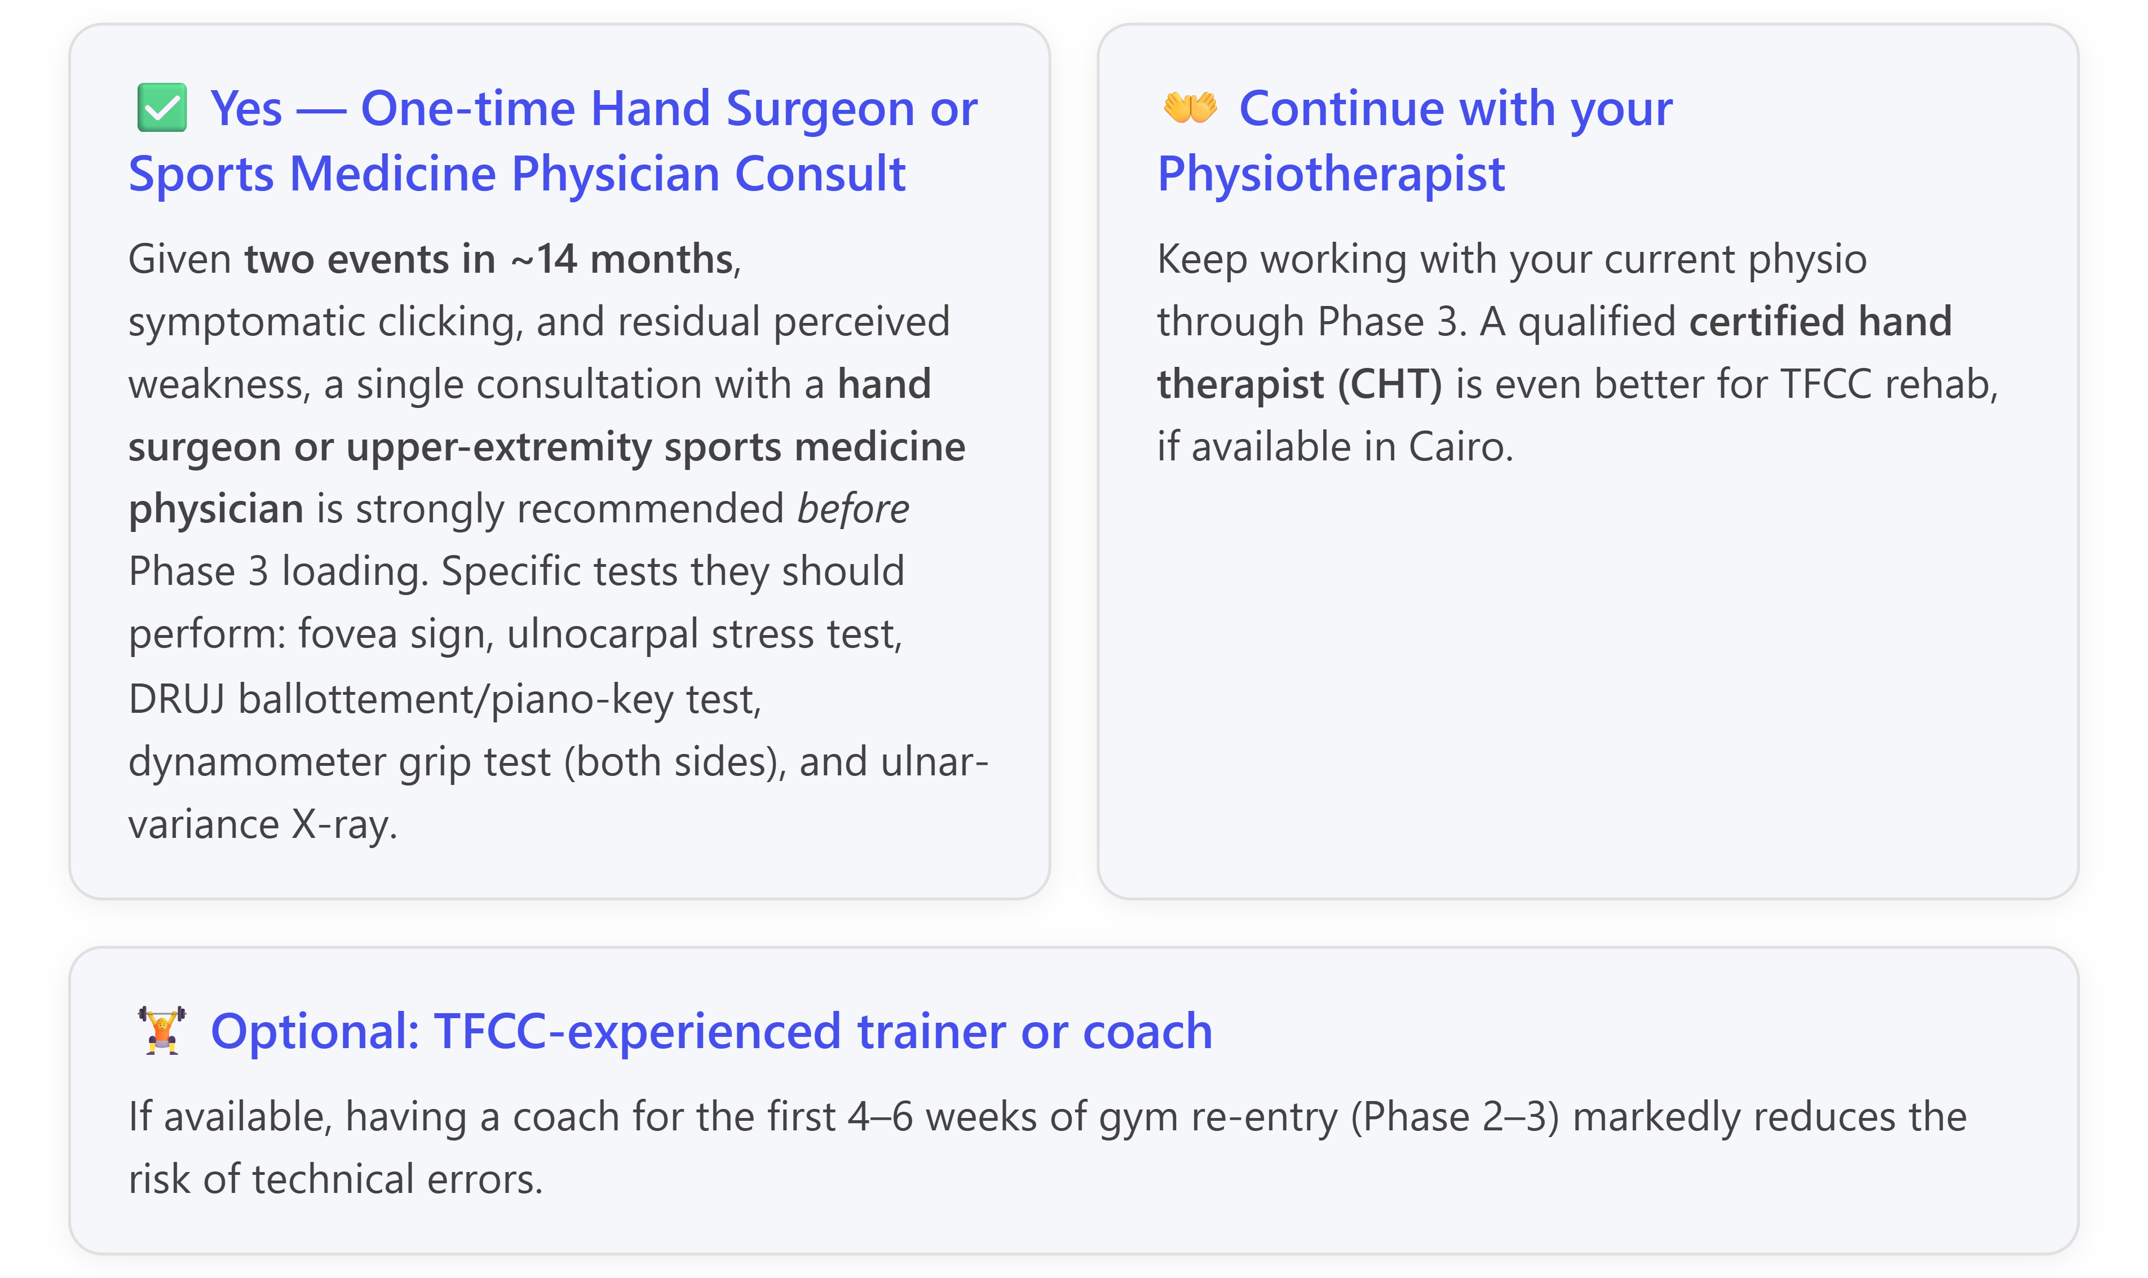

7.3 Are you likely to need surgery?
Probably not, based on your current data. The literature consensus:
- Initial management for all Type 1 injuries is nonoperative (immobilization, NSAIDs, rehab).
- The gold-standard threshold is failed conservative treatment for at least 6 months before considering surgery.
- For central Palmer 1A tears specifically, if surgery is eventually needed, the procedure is arthroscopic debridement (not repair, because the tissue is avascular).
- Even after surgical debridement, only ~44% of patients are completely pain-free at follow-up, though 92% return to work/sport.
- Debridement can safely remove up to 80% of the central disc without affecting DRUJ or radiocarpal biomechanics.
Your current profile (pain-free at rest, preserved DRUJ, no instability, no positive ulnar variance documented) puts you squarely in the group that should exhaust structured conservative care first. Realistically, the probability you will ever need surgery is likely modest (rough estimate 15–30%) as long as you follow a proper phased return.

7.4 What about biologic / regenerative options?
You may see marketing for PRP or stem-cell injections for TFCC. The evidence is currently limited and inconsistent, and none of the major hand-surgery guidelines currently endorse them as first-line. Focus your resources on: (i) objective clinical assessment, (ii) structured rehab, (iii) ergonomic and gym modifications.

8. Consolidated Answer Summary
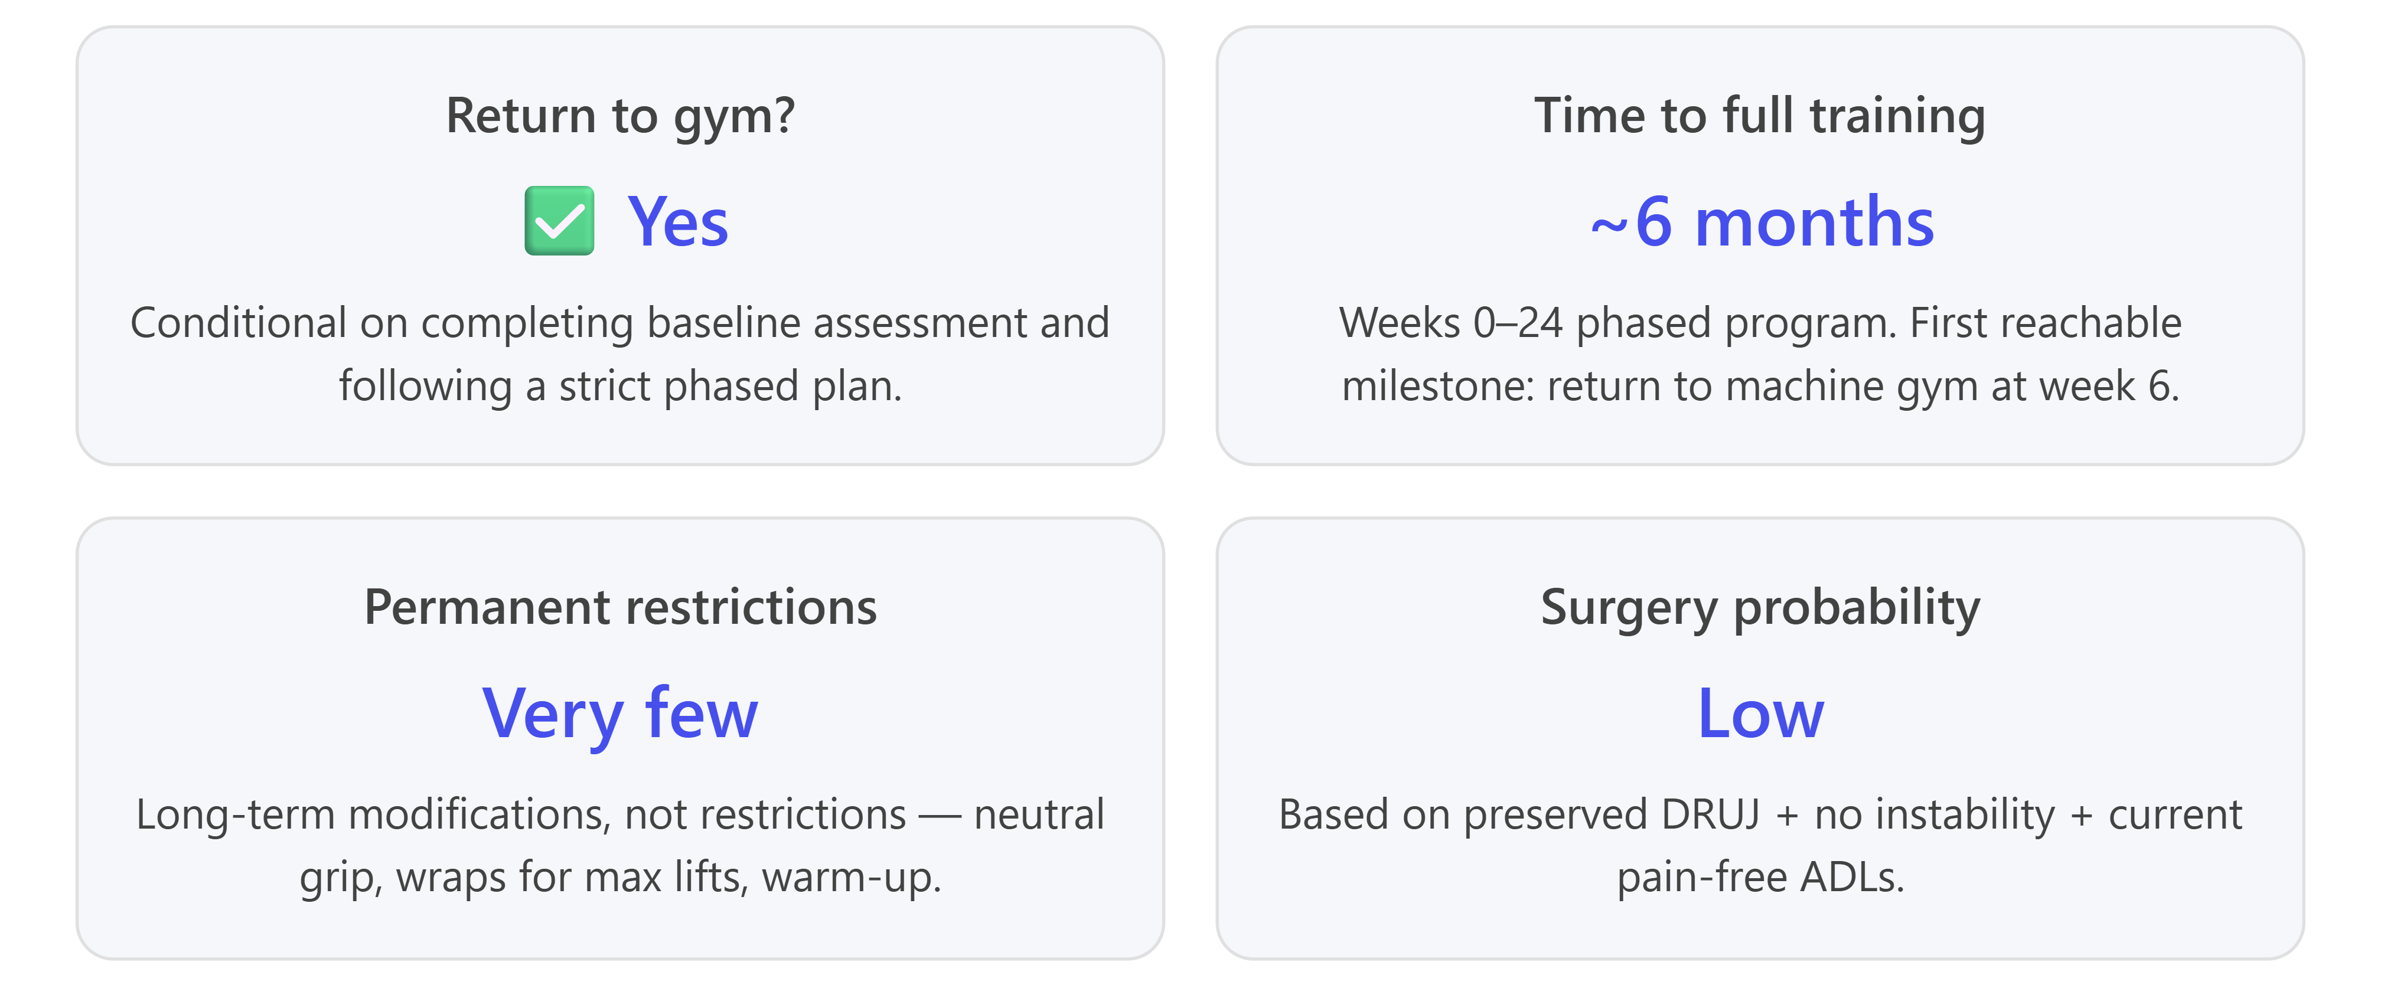

8.1 Direct answers to each question
1. Return to Training: Yes, medically safe to plan a return now, but not immediate resumption of your previous routine. Only a handful of high-risk movements (weighted dips at max, kettlebell snatches, planche work, handstands) warrant lifelong caution. All conventional lifts are recoverable.
2. Injury Relationship: Related but at different anatomical sites. The 2024 finding fits a peripheral (Palmer 1B–pattern) partial detachment; the 2026 finding is a central Palmer 1A perforation. The second event is not necessarily a failure of the first treatment — it more likely reflects premature return before dynamic stabilizers were reconditioned, plus the inherently non-healing nature of the central disc. The good news: DRUJ is imaging-stable in 2026 and marrow edema has resolved — that's actually improvement structurally.
3. Exercise Restrictions:
- Avoid for 6–8 weeks: full push-ups, planks on extended wrists, barbell bench, dips, weighted pull-ups, kettlebell work, front squats, handstands.
- Reintroduce carefully in weeks 8–16: DB bench (neutral grip), EZ-bar curls, cable/machine work, wall→table→knee→full push-ups on handles, band-assisted pull-ups.
- Long-term OK with technique: barbell bench with wraps, deadlifts with straps, neutral-grip pull-ups.
- Order of preference: Machines > Cables > DBs (neutral) > EZ bar > Straight barbell.
4. Rehab & Comeback Plan: Six phases spanning 24+ weeks (see §5 and timeline chart). Progression rules: 3/10 pain limit, weekly load increments, three consecutive pain-free sessions before advancing.
5. Risk Management: Clear red flags identified (§6.1). Biggest re-injury risks are: returning too early, ignoring dynamic stabilizer training, dominant-hand overuse, unknown ulnar variance, and volume errors in barbell pressing.
6. Medical Follow-up: MRI arthrogram not needed now, but useful before any surgical decision. One-time hand-surgeon / sports-medicine consult recommended to formally test DRUJ stability, fovea sign, grip strength ratio, and measure ulnar variance on X-ray. Surgery probability is low given your current status.

9. Key Assumptions I Made in This Analysis
- You are actually asymptomatic with ADLs — you reported no pain in daily use. If you have pain with any provocative daily task (turning a key, opening a jar, pushing up from a chair, wringing a towel), that changes the recommendation and warrants specialist review before Phase 1.
- Your DRUJ is truly stable — the 2026 MRI describes "preserved distal radioulnar articular relation" but this needs to be confirmed with a clinical DRUJ ballottement / piano-key test before you load the wrist. Imaging stability ≠ clinical stability under load.
- Ulnar variance is neutral or negative — never quantified in either report. If it turns out to be positive > 2 mm, prognosis for conservative management worsens and ulnar-shortening surgery becomes a serious secondary option.
- Your rehab was properly progressive — completing 8/10 sessions is good, but if they were mostly modalities (ultrasound, electrical stim, massage) without progressive loading and dynamic stabilizer work, you may still have a "rehab gap" that needs closing before returning to gym.
- The clicking is painless — if the clicking is painful or associated with a catch/lock sensation, that's a different clinical picture requiring imaging re-evaluation.

10. Immediate Next Steps (Prioritized Action List)
- This week: Book a single specialist consult (hand surgeon or upper-extremity sports doctor). Bring both MRI CDs, both reports, and this analysis.
- At that visit request: (a) fovea sign, (b) DRUJ ballottement / piano-key, (c) ulnocarpal stress test, (d) dynamometer grip test both sides, (e) zero-rotation PA X-ray to measure ulnar variance.
- Within 2 weeks: Start Phase 0/1 (wrist ROM, 6-way isometrics, ECU/PQ activation, putty grip). These are safe now regardless of specialist findings.
- Weeks 2–6: Confirm progression with your physio; add machine-based lower-body gym work. Wear a WristWidget-style brace during any household activity that provokes discomfort.
- Week 6: Objective re-check → grip strength ratio ≥80%, symmetric ROM, no fovea tenderness → begin Phase 2 (machine upper-body).
- Ongoing: Track sessions in a training log with pain rating and note any latent (24 h) pain.

If you can share the original MRI images, I can look at the coronal STIR and PD-fat-sat sequences to specifically comment on: (i) exact location and size of the central perforation, (ii) whether there is residual peripheral (foveal or styloid) signal change, and (iii) rough ulnar variance on the coronal view.

https://academic.oup.com/bjr/article-abstract/99/1181/872/8506508
https://www.orthobullets.com/hand/6047/triangular-fibrocartilage-complex-tfcc-injury
https://www.orthobullets.com/hand/6047/triangular-fibrocartilage-complex-tfcc-injury
https://www.orthobullets.com/hand/6047/triangular-fibrocartilage-complex-tfcc-injury
https://www.advancedhand.com.sg/wrist-specialist-singapore/tfcc-tear-in-sports-symptoms-diagnosis-and-treatment/
https://academic.oup.com/bjr/article-abstract/99/1181/872/8506508
https://www.drfilipcosic.com/rehab_pdfs/14_TFCC_repair.pdf
https://www.advancedhand.com.sg/wrist-specialist-singapore/tfcc-tear-in-sports-symptoms-diagnosis-and-treatment/
https://www.advancedhand.com.sg/wrist-specialist-singapore/tfcc-tear-in-sports-symptoms-diagnosis-and-treatment/
https://www.droracle.ai/articles/627430/what-is-the-treatment-for-a-full-thickness-tear
https://europepmc.org/article/MED/32788827
https://europepmc.org/article/MED/32788827
https://europepmc.org/article/MED/32788827
https://www.droracle.ai/articles/627430/what-is-the-treatment-for-a-full-thickness-tear
https://link.springer.com/content/pdf/10.1007/s00068-020-01315-2.pdf
https://myhealth-hand-symptomchecker.com/blog/wrist-clicking-guide
https://www.advancedhand.com.sg/wrist-specialist-singapore/tfcc-tear-in-sports-symptoms-diagnosis-and-treatment/
https://www.advancedhand.com.sg/wrist-specialist-singapore/tfcc-tear-in-sports-symptoms-diagnosis-and-treatment/
https://www.droracle.ai/articles/627430/what-is-the-treatment-for-a-full-thickness-tear
https://treattfcc.org/exercises
https://treattfcc.org/exercises
https://treattfcc.org/exercises
https://treattfcc.org/exercises
https://whatsnewinfitness.com.au/training-clients-with-tfcc-injury-a-practical-guide-for-fitness-professionals/
https://whatsnewinfitness.com.au/training-clients-with-tfcc-injury-a-practical-guide-for-fitness-professionals/
https://treattfcc.org/exercises
https://whatsnewinfitness.com.au/training-clients-with-tfcc-injury-a-practical-guide-for-fitness-professionals/
https://treattfcc.org/exercises
https://whatsnewinfitness.com.au/training-clients-with-tfcc-injury-a-practical-guide-for-fitness-professionals/
https://treattfcc.org/exercises
https://treattfcc.org/exercises
https://treattfcc.org/exercises
https://treattfcc.org/exercises
https://treattfcc.org/exercises
https://treattfcc.org/exercises
https://treattfcc.org/gym-guide
https://treattfcc.org/gym-guide
https://treattfcc.org/exercises
https://whatsnewinfitness.com.au/training-clients-with-tfcc-injury-a-practical-guide-for-fitness-professionals/
https://treattfcc.org/exercises
https://treattfcc.org/exercises
https://whatsnewinfitness.com.au/training-clients-with-tfcc-injury-a-practical-guide-for-fitness-professionals/
https://europepmc.org/article/MED/32788827
https://whatsnewinfitness.com.au/training-clients-with-tfcc-injury-a-practical-guide-for-fitness-professionals/
https://whatsnewinfitness.com.au/training-clients-with-tfcc-injury-a-practical-guide-for-fitness-professionals/
https://www.ncbi.nlm.nih.gov/pmc/articles/PMC6244851/
https://www.ncbi.nlm.nih.gov/pmc/articles/PMC6244851/
https://www.orthobullets.com/hand/6047/triangular-fibrocartilage-complex-tfcc-injury
https://www.orthobullets.com/hand/6047/triangular-fibrocartilage-complex-tfcc-injury
https://www.droracle.ai/articles/627430/what-is-the-treatment-for-a-full-thickness-tear
https://www.orthobullets.com/hand/6047/triangular-fibrocartilage-complex-tfcc-injury
https://www.droracle.ai/articles/627430/what-is-the-treatment-for-a-full-thickness-tear
https://europepmc.org/article/MED/32788827
https://europepmc.org/article/MED/32788827
https://europepmc.org/article/MED/32788827

